Practical 3
Aim:-Decision tree learning
import numpy as np
import pandas as pd
PlayTennis= pd.read_csv("D:\AI practical\PT\PTcsv\PlayTennis.csv")

print(PlayTennis,"\n\n")

from sklearn.preprocessing import LabelEncoder
Le= LabelEncoder()

PlayTennis['Outlook']=Le.fit_transform(PlayTennis['Outlook'])

PlayTennis['Temperature']=Le.fit_transform(PlayTennis['Temperature'])

PlayTennis['Humidity']=Le.fit_transform(PlayTennis['Humidity'])

PlayTennis['Wind']=Le.fit_transform(PlayTennis['Wind'])

PlayTennis['Play Tennis']=Le.fit_transform(PlayTennis['Play Tennis'])

print(PlayTennis,"\n\n")

y=PlayTennis['Play Tennis']
X=PlayTennis.drop(['Play Tennis'], axis=1)

from sklearn import tree

clf=tree.DecisionTreeClassifier(criterion='entropy')
clf=clf.fit(X, y)

print(tree.plot_tree(clf),"\n\n")

import graphviz
dot_data=tree.export_graphviz(clf, out_file=None)
graph=graphviz.Source(dot_data)
print(graph)
# python shell can't print graph image so, it will print the code for diagraph implementation

X_pred=clf.predict(X)
print(X_pred==y,"\n")

Output:-
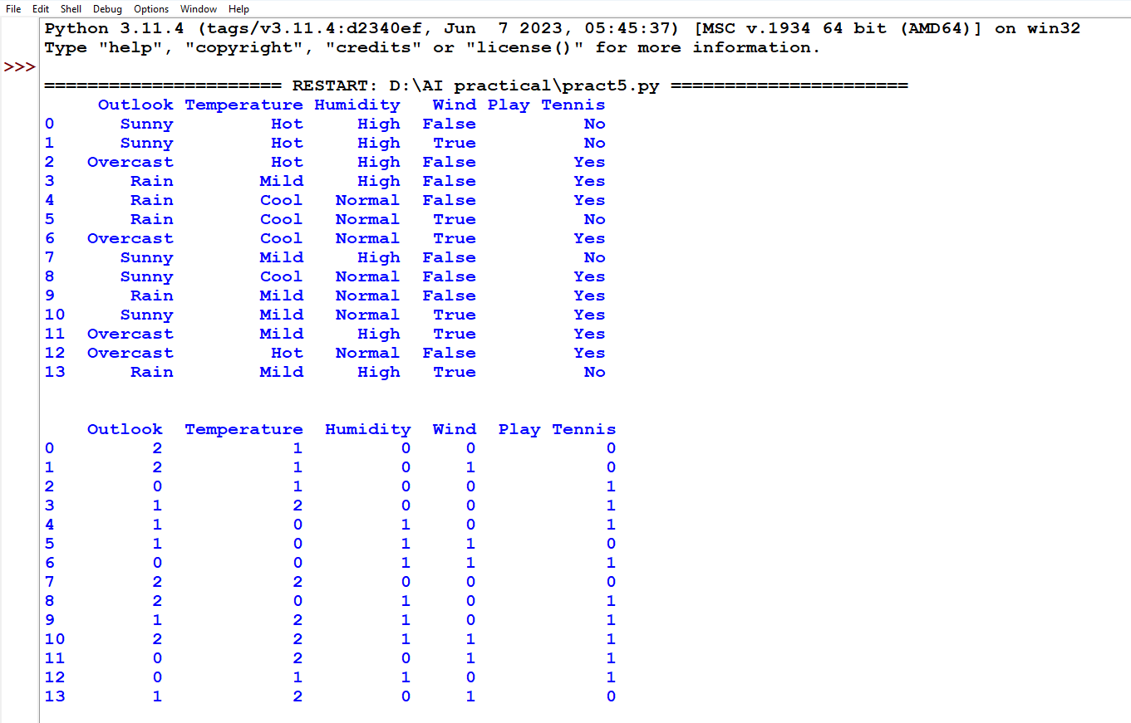
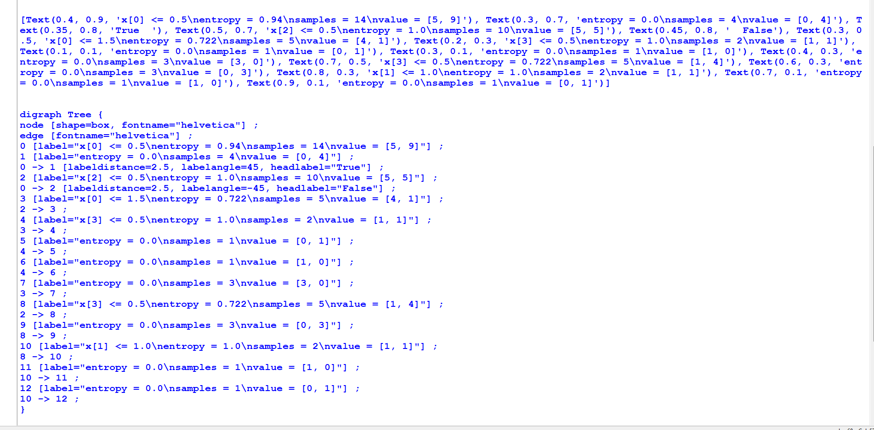
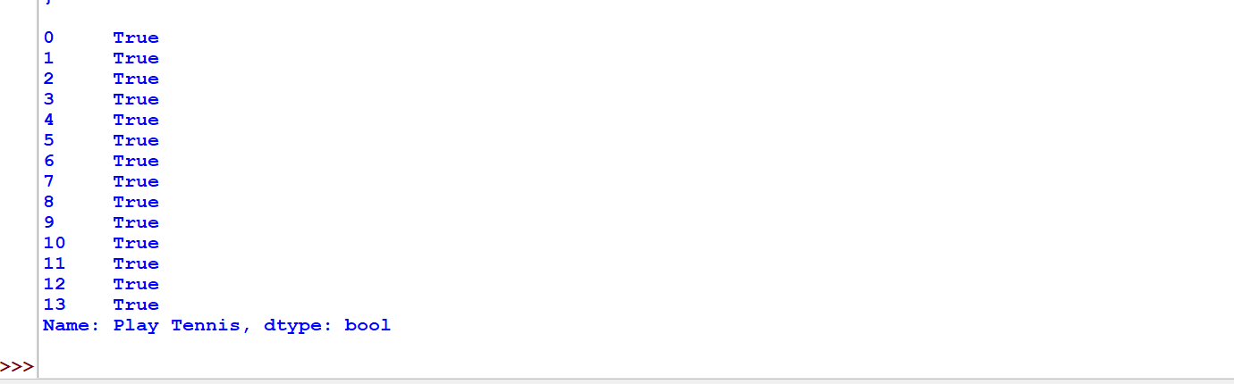
Practical 4
Aim:-Feed Forward Backpropagation neural network
from doctest import OutputChecker
import numpy as np
class NeuralNetwork():
def __init__(self):
np.random.seed()
self.synaptic_weights=2*np.random.random((3,1))-1
def sigmoid(self,x):
return 1/(1+np.exp(-x))
def sigmoid_derivative(self,x):
return x*(1-x)
def train(self,training_inputs,training_outputs,training_iteration):
for iteration in range(training_iteration):
output=self.think(training_inputs)
error=training_outputs-output
adjustments=np.dot(training_inputs.T,error*self.sigmoid_derivative(output))
self.synaptic_weights+=adjustments
def think(self,inputs):
inputs=inputs.astype(float)
output=self.sigmoid(np.dot(inputs,self.synaptic_weights))
return output
if __name__ == "__main__":
neural_network = NeuralNetwork()
print("Beginning Randomly Generated Weights: ")
print(neural_network.synaptic_weights)
training_inputs = np.array([[0,0,1],[1,1,1],[1,0,1],[0,1,1]])
training_outputs = np.array([[0,1,1,0]]).T
neural_network.train(training_inputs,training_outputs,15000)
print("Ending Weights After Training : ")
print(neural_network.synaptic_weights)
user_input_one=str(input("User Input One: "))
user_input_two=str(input("User Input Two: "))
user_input_three=str(input("User Input Three: "))
print("Considering New Situation: ", user_input_one, user_input_two, user_input_three)
print("New Output Data : ")
print(neural_network.think(np.array([user_input_one,user_input_two,user_input_three])))

OUTPUT:-
